Questions for Office hour

For problem 3:

How is this different from the projection equations? Where did x0 and y0 go?

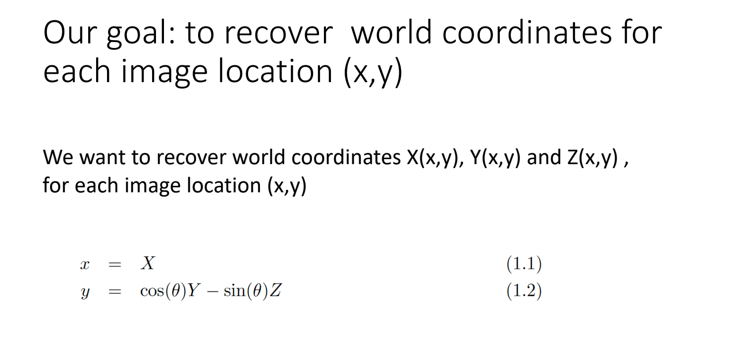

I know the homework asks for constrains for Z, but can you go over the constraints for Y again? There are still things I’m confused. For example, why is Z constant along the edge for vertical edges and Y constant along the edge for horizontal? Also, why taking derivative in regards to y and t? How can I understand the role of t in this situation? And why do we take second derivatives? I guess I don’t get a big picture here so hope you can go over constraints for Y again so that I can apply my understanding in solving for Z?

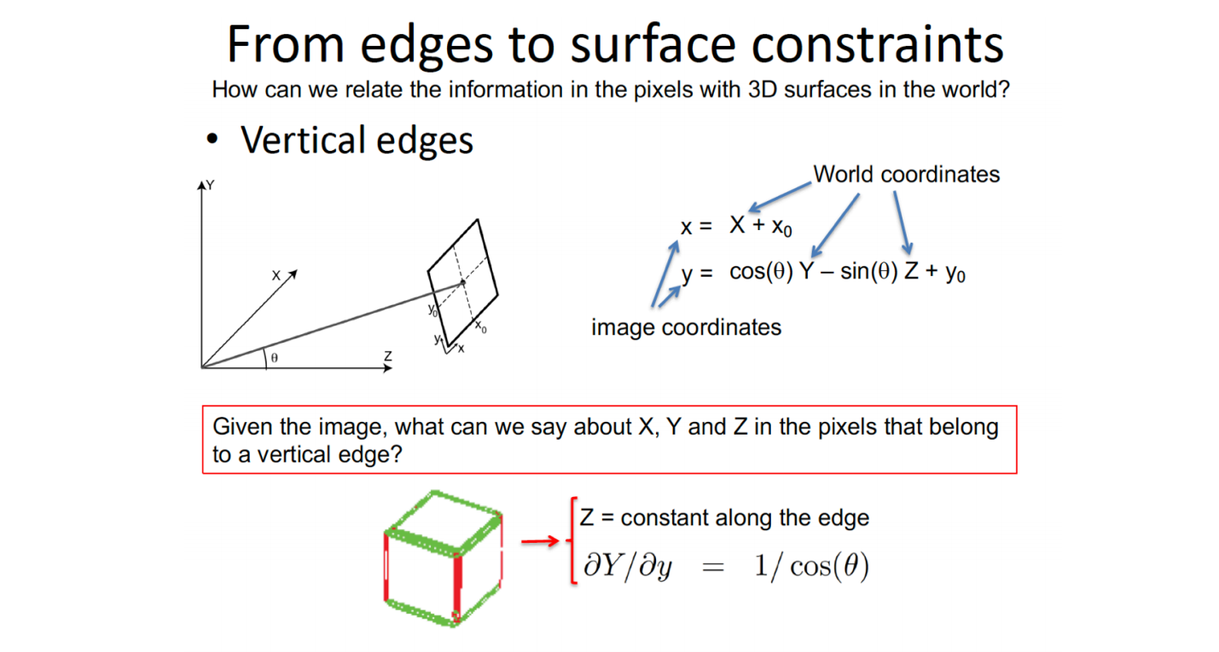

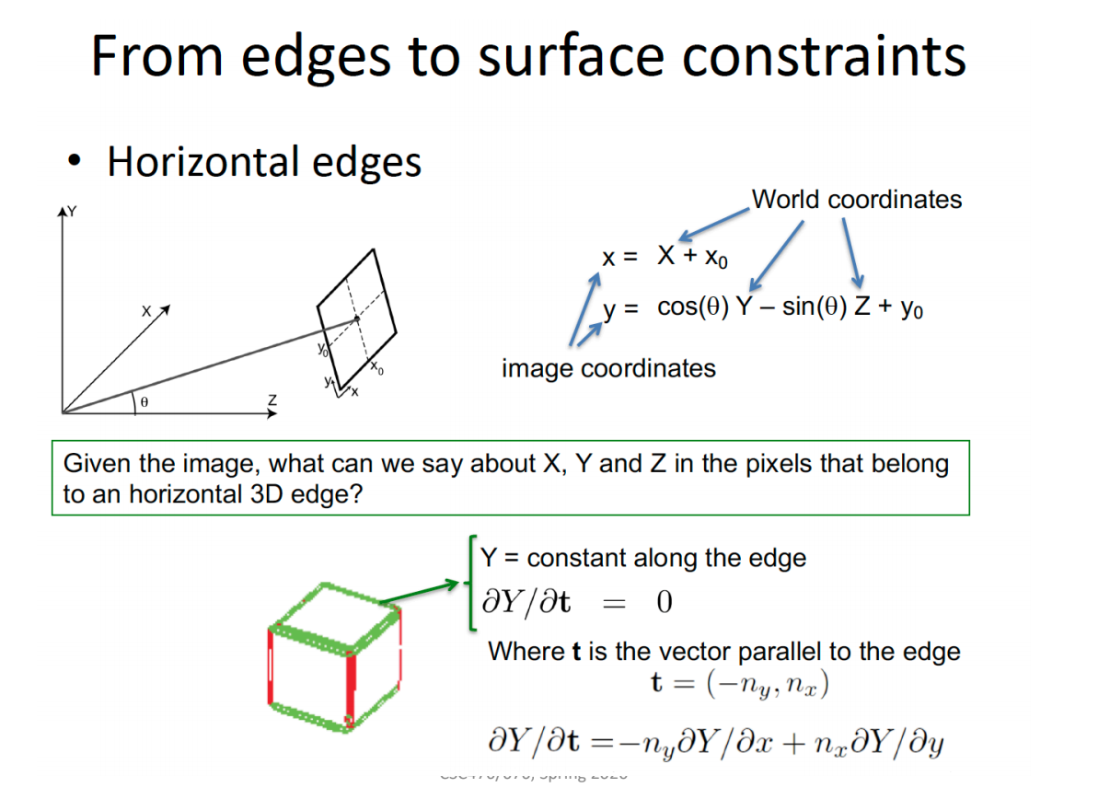

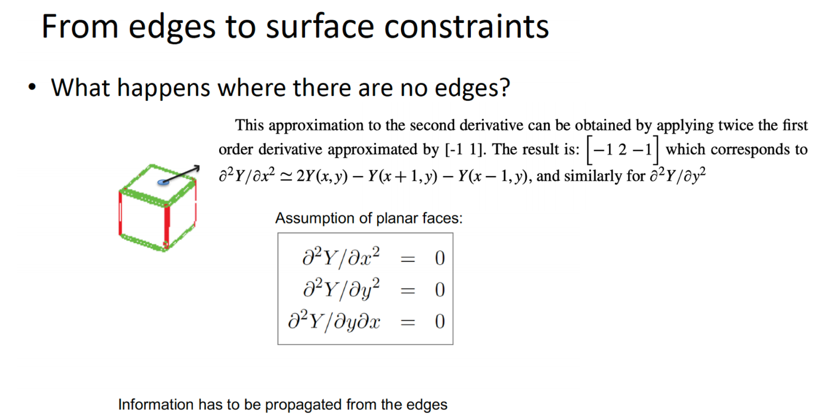

For problem 4:

Can you elaborate on the lecture slide below? Are we computing derivatives here? How do I know if this is the vertical or the horizontal derivative? Why ¼? Also, I searched online about the sobel operator and it seems the kernel changes. How do we know which kernel matrix to use?